**System Design Document**

**For**

**Mental Health Application**

Team members:

* Lizzy Jackson
* Garðar Benediktsson
* Harrison Dinius
* Jason Hansen
* Gabi Stoney

|  |  |
| --- | --- |
| Version/Author | Date |
| V1; Lizzy Jackson, Garðar Benediktsson, Gabrielle Stoney, Harrison Dinius | 09/29/2020 |
| V1.2; Harrison Dinius | 10/1/2020 |
| V2; Lizzy Jackson, Garðar Benediktsson | 10/28/2020 |
| V2.1; Lizzy Jackson | 11/12/2020 |
| V2.2; Lizzy Jackson | 11/17/2020 |
| V3; Gabrielle Stoney, Harrison Dinius, Garðar Benediktsson, Jason Hansen | 11/30/2020 |

TABLE OF CONTENT

1 INTRODUCTION 3

1.1 Purpose and Scope 3

1.2 Project Executive Summary 3

1.2.1 System Overview 3

1.2.2 Design Constraints 3

1.2.3 Future Contingencies 3

1.5 Glossary 4

2 System Architecture 5

2.1 System Hardware Architecture 5

2.2 System Software Architecture 5

2.3 Internal Communication Architecture 5

3 HUMAN-MACHINE INTERFACE 5

3.1 Inputs 5

3.2 Outputs 10

4 DETAILED DESIGN 11

4.1 Hardware Detailed Design 11

4.2 Software Detailed Design 11

4.3 Internal Communications Detailed Design 13

5 External Interfaces 13

6 System Integrity controls 13

SYSTEM DESIGN DOCUMENT

# INTRODUCTION

## Purpose and Scope

The purpose of this document is to visualize the design and scope of the user interface for the Mental Health Application. All components of the application will be designed and summarized within this document.

## Project Executive Summary

This document describes the system requirements, operating environment, system and subsystem architecture, files and database design, input formats, output layouts, detailed design, processing logic, and external interfaces for the Mental Health Application.

### **System Overview**

The goal of the Mental Health Application system is to collect data from the user’s communications on their mobile device and create tiers of contacts to help the user track and maintain their own mental health by keeping them in touch with friends and family. This application would help with this by encouraging the user to contact friends when they fall behind on frequency of contacting them. It would keep up relationships, especially in times of COVID quarantine when human contact is few and far in between. The subsystems at work to achieve this include data collection, data storage, the algorithm, and the user interface. The data collection system accesses user contacts and communication history and sends it to the data storage system for organizing and saving what was collected. The algorithm processes the data to create tiers for the user’s contacts, from most-to-least important. The user interface system displays those results to the user, which are also sent back to the data storage system for saving and future use by the algorithm.

### **Design Constraints**

The team is making several assumptions when developing this project, which are as follows:

* User has an iPhone updated to the latest version of iOS 13.7
* User is communicating with at least 1 person
* User communication is occurring on a daily basis

### **Future Contingencies**

Integration of Firebase as a database solution for outsourcing data storage and calculation is tentatively scheduled, due to complete unfamiliarity with it (and low priority relative to the rest of the backlog). If Firebase integration is not fulfilled, the alternative plan is to keep everything stored locally in the application on the user’s device.

**1.3 Document Organization**

This document is designed to give the reader an idea of the system design. The following sections will provide information on what the product does, limitations, interactions, interfaces, hardware and software designs, and security.

**1.4 Project References**

1.4.1 Legal Guide on Age Requirements for Application Usage in the US <https://www.ftc.gov/enforcement/rules/rulemaking-regulatory-reform-proceedings/childrens-online-privacy-protection-rule>

## 1.5 Glossary

Communication/Communicating: For the purposes of this document, communication is a broad term used to refer specifically to calling, texting, and FaceTime only.

# System Architecture

This section describes and overview of the hardware and software architecture for the Helping Hands Application system.

## System Hardware Architecture

This section does not apply to the Helping Hand Application

## System Software Architecture

The Helping Hands application is written in the programming language Swift 4 in the developing tool Xcode version 12.2. There are four different screens throughout this application. The home screen will allow a user to look at the different screens the application can go to (See Circles, Block Nr, Weights). The See Circles screen will display up to five people of a user's top five contacts generated by the algorithm. The Block Nr screen allows for a user to see all of their contacts and select which one will be blocked. The Weights screen will allow a user to change the weights that a certain form of communication might have (Facetime, Calls, Text). Below is the data flow diagram that displays how the information will be moved throughout the application.

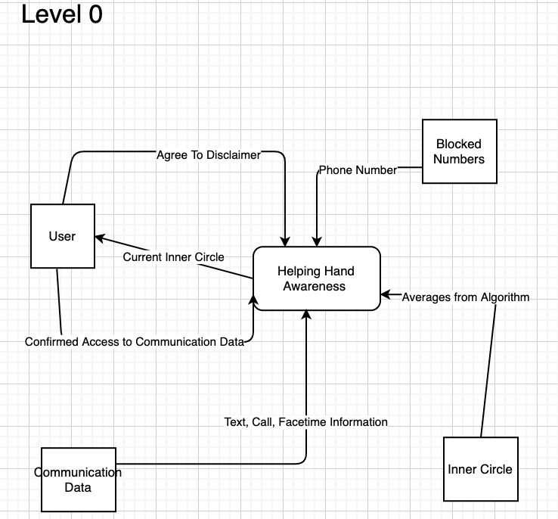

Figure 2.2.1 - Data Flow Diagram: Level 0

This diagram is used to show how the data will flow throughout the system. There are four sources/sinks: User, inner circle, blocked numbers, and communication data. These sources/sinks will receive and take data from the system. Level 0 is meant to the system as a whole and now all of the processes that will take the data coming from the sources and do something with it.

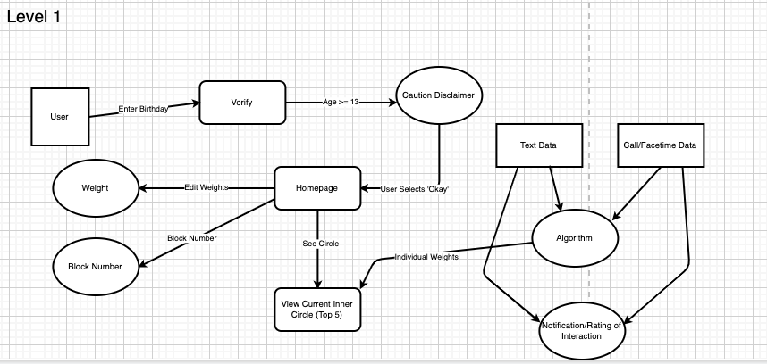

Figure 2.2.2 - Data Flow Diagram: Level 1

This diagram is used to show how the data will flow throughout the system. Level 1 has more processes that describe what will happen to the data. For example, in the figure 2.2.2, we see there is a process such as “Algorithm”. This process will calculate all of a user's individual data from calls, texts and facetime and send the data called “individual weights”.

## Internal Communication Architecture

This section does not apply to the Helping Hand Application

# HUMAN-MACHINE INTERFACE

This section provides the detailed design of the system and subsystem inputs and outputs relative to the user/operator. Any additional information may be added to this section and may be organized according to whatever structure best presents the operator input and output designs. Depending on the particular nature of the project, it may be appropriate to repeat these sections at both the subsystem and design module levels. Additional information may be added to the subsections if the suggested lists are inadequate to describe the project inputs and outputs.

## Inputs

The application needs the user’s permission to be able to access their contacts (Figure 3.1.1). This is done to allow the user to control their privacy. The application uses the data from the user’s contacts in the algorithm to calculate the inner circle.

Figure 3.1.1 - Requires user to give access to contacts.

The user needs to input the desired weight for each mode of communication (Figure 3.1.2). These weights will then be applied to the algorithm.

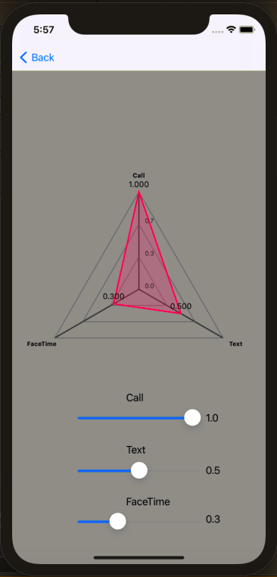

Figure 3.1.2 - Allows user to change weight (importance) of each mode of communication; call, text, and Facetime.

Furthermore, should a user choose to block a number (Figure 3.1.3) from being included in the calculations, then they may enter that number in the application. Cases such as this may stem from communicating with someone about work, a project, or relations other than close friends and family.

Figure 3.1.3 - Application allows user to block numbers from being calculated in algorithm.

In figure 3.1.4, the initial window will be as shown when the user opens the application. From this first page (a welcome screen) the user will be able to select seeing their circle, blocking a number, or adjusting the weights of various forms of communications. Please see above figures and explanations for understanding of these options.

**Application Layout:**

Figure 3.1.4 - Welcome screen of application

Below, Figures 3.1.5 and 3.1.6 show the push notification that pop up after a large block of communication (e.g. a long text conversation of rapidly sent and received messages that last for longer that one or two text messages).

Figure 3.1.5 - Application pushes notification Figure 3.1.6 - Application pushes notification to ask if the interactions was to ask user how much of an impact negative or positive the interaction had.

## Outputs

The user application will output the names of the contacts that are in the user’s inner circle. The application will run the algorithm to determine which contacts to display (Figure 3.2.1).

Figure 3.2.1 - Screen displaying inner circle of numbers application has access to.

# DETAILED DESIGN

## Hardware Detailed Design

There is no hardware component for Helping Hands Application.

## 4.2 Software Detailed Design

State Chart

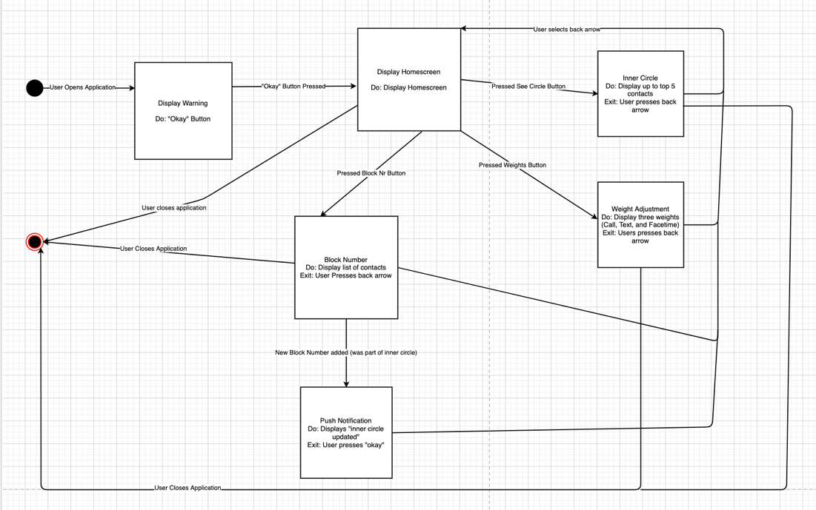

Figure 4.2.1 - State Chart

The state chart describes what chain of events must happen in order for the application to move into the next state. In figure 4.2.1 a user must select a specific button in order to move from the home screen to either the block number section, calculated circles or changing the weights of the algorithm.

Use Case Diagram

Figure 4.2.4 - Use Case

The use case diagram is to get an understanding of who will be interacting with the system and what processes will be performed in the system. For example, in figure 4.2.2, the user will interact with the system by using the specific process titled “Browse Contact List”.

## 4.3 Internal Communications Detailed Design

The data that is flowed throughout the system come from three main components. The Block Nr screen allows the data from a user’s contacts to be looked at. Access to a user’s contacts also mean the system will have access to the different forms of communication. This data is utilized in the See Circle screen. The See Circle screen will gather the information from the contact information and plug that into the algorithm that will calculate how a user may trust that contact. The last screen, weights will allow a user to change how the different forms of communications are weighted. That information is then sent and used by the See Circle page and will change a contact’s trust algorithm accordingly.

# External Interfaces

This section does not pertain to the Helping Hands Application project.

# System Integrity controls

The system will use iTunes backup storage to access text, call and Facetime logs. The length of communication, and what type of communication it was will be pulled by the system to put into the algorithm.

For now, the logs allow access to text content, but this will be blocked from the app by converting the data into a different file. This will protect the user's privacy but still allow use of the app. Numbers will still be able to be blocked should a user want to cease access.

There are only software related integrity controls, no hardware or physical controls for this application.

The application may require use of Google’s Firebase to allow the app to store this data and factor everything into the algorithm, rather than just the most current uploaded data.